Returning to College as a Veteran
Transitioning from military life to life as a college student provides you with many benefits as well as a few challenges.

Advantages of Going Back to College
After serving in the military, a return to civilian life can be difficult. This is particularly true if you haven't yet earned an undergraduate or master's degree. Deciding to enter an educational program as a veteran can increase your job opportunities and earning power while it will also make your transition back to civilian life a smoother one.
As a college student, you'll meet other students, helping you become comfortable once again with non-military life. In fact, some universities even have programs that are tailored to help veteran students transition to civilian life.
Working towards a degree can help you earn more than twice as much money in the job market than those with a high school diploma will earn. Having that college or master's degree can also make you eligible for the type of job you've dreamed of having.
If you've been in the military since you were a teenager, you probably weren't sure of what your future career goals would be. Now that you're a veteran, you may have a better grip on what you want to do professionally, and college can help you get there.

Challenges Veteran Students Face
Up to 16% of military veterans return home and are diagnosed with mental health issues. Some conditions include post-traumatic stress disorder, depression, and substance use disorders. Others have suffered physical disabilities, while some veteran students are still on active-duty status.
Other challenges include:
- Paying for college.﻿ Navigating the Veterans Benefits Administration can be frustrating, yet VA benefits can often help pay for the bulk of college costs. The GI Bill and other educational benefits are available to you if you spend the time and effort to apply for them.
- Retention. The more rigid lifestyle and learning regimens in the military can lead to about 16% of veteran students dropping out of school due to difficulties adapting to campus and classroom life.
- Mental health. Veterans who suffer from PTSD symptoms can experience difficulty fitting in with their college peers who were not in the military.
- Age differences.﻿ Most veterans going back to college are older than the typical college student who is just 18 years old. This can feel alienating and even boring to you if you're stuck in classrooms with teenagers.
- Anti-military biases. Your younger college peers may tend to hold liberal or anti-war and anti-military sentiments that can further lead to feelings of isolation and negativity.

Earning a Degree Online
You can navigate and even eliminate some of the challenges presented to a veteran student by enrolling in a more flexible online degree program rather than an in-person college experience. Studying for an online master's degree in IT, for example, will help you gain expertise and information about:
- IT management
- Data analytics
- Cybersecurity
- Computer science
- Information systems

Resources For Veterans in College
There are many advantages to completing your college degree after military service, including studying towards a lucrative career and making a positive transition back to civilian life. Check out the many sites available to help veterans navigate benefits and other helpful organizations.
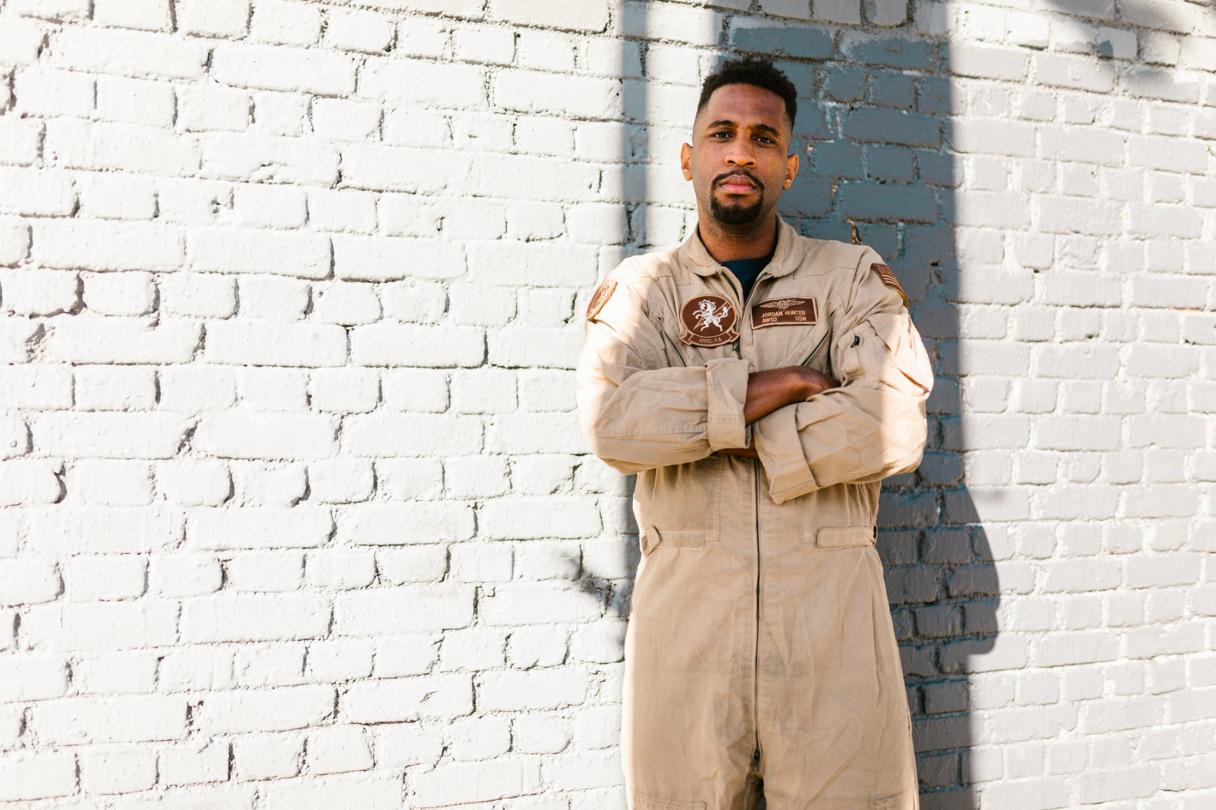
Image via Pexels

